presents

A Simplified Pocket eBook on…

Cassette Tapes and Players for Starters
Update 0 Revision 3 by Brendon, 06/10/2021.
Contents
I: Terms 4
II: Cassette Tapes 5
A: Background 5
B: Cassette Tape Anatomy 6
C: Tape Lengths 9
D: Handling Cassette Tapes 11
E: (Optional) Tape Types 13
III: Cassette Players 15
A: Loading Cassettes 15
B: Playing Cassette Tapes 17
C: Transport Anatomy 20
D: Care and Maintenance 22
D1: Cleaning 24
IV: Troubleshooting 26
V: Repair Services 31
A: About Repair Shops 31
B: Alternative Option 32
VI: Trivia 34
VII: Endnote 38
License 39

I: Terms
"Compact Cassette" is the official name of the format.
"Cassette tape" refers to a cassette of tape, and is a colloquial name of the format.
"Cassette" refers to the same thing. But "tape" also refers to adhesive tape.
"Cassette deck" refers to high-fidelity cassette recorders that are usually big and heavy. Cassette recorders can play cassette tapes.

II: Cassette Tapes

A: Background
The Compact Cassette is an analog magnetic tape recording format, primarily used for storage and retrieval of audio signals.
In the late 1970s, the Walkman brand—referring to Sony's line up of portable cassette players—popularized the idea of listening to music on the go, hence being the original predecessor to our modern music culture.
With streaming as the contemporary way of music, the Compact Cassette still lives as a niche format.

B: Cassette Tape Anatomy
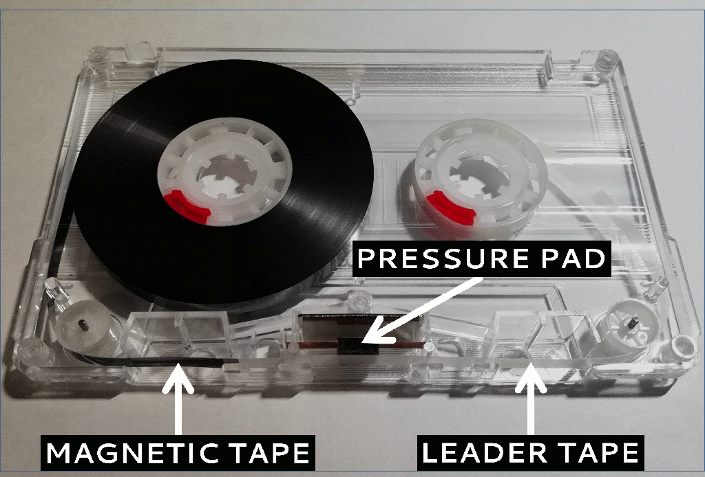Image: A cassette tape with its shell opened. Be extremely careful when disassembling cassette tapes, or you will be treating yourself a nightmare.
Magnetic Tape | Contains recorded material.
Leader Tape | Protects magnetic tape from pulling force exerted when the tape reaches its ends.
Pressure Pad | Maintains contact between tape and head.
In the conventional forward direction, tape unwinds from the supply (left) reel, passes the pressure pad, then winds around the take-up (right) reel.
In the same convention, the width of the magnetic tape is split into four tracks. Two for each of the two sides: A and B, in which one for each of the stereo channels: left and right. Sides are recorded in the opposite direction of one another.
Forward Left >>
Forward Right >>
<< Reverse Right
<< Reverse Left
Illustration: Tracks within the width of the magnetic tape, where the head is below and pressure pad is above. If we look at the tape into the cassette, then this illustration would be vertically flipped. In actuality, there are gaps between these tracks to minimize cross-talk.
Monaural recordings combine the left and right tracks of each side into one. Alternatively, there are specialized recorders that treat each of the four tracks as a monaural channel.

C: Tape Lengths
Cassette tapes are sold at different lengths, mostly by their standard recording time.
These are referred to with the "C-" prefix, so a 60-minute tape—30 minutes per side—is called a C-60.
Lengths longer than C-60 may have thinner, weaker, and more fragile tape to be able to fit in fix-sized cassettes. C-90 is a good, popular cut-off before diminishing returns become significant.
The shortest length is C-0, that are cassettes with no tape.
The longest known length is C-180, loaded with very thin, very weak, and very fragile tape. It is very rare but not recommended for use. C-120 tapes are also not recommended unless used with caution.
There are deviations between different tapes of the same marketed length. For example, a C-90 can be a C-94 in actuality. The extra length is intentional not only to compensate over speed deviations among different cassette recorders, but also to let that last song of yours to finish uninterrupted.
However, sellers who take account of tape length deviations may be selling tape in their actual lengths, so their C-90 may be an actual C-90.

D: Handling Cassette Tapes
1 Do not touch the tape, unless required for repair, in which case then wash your hands with soap to get rid off as much grease as possible.
2 Rewind and stow them into their cases when you are finished using them to protect the recorded parts from exposure.
3 Keep them contained within their cases in cold, dry places.
4 It is suggested to hold them with clean hands, just in case of accidentally touching the tape.
5 DO NOT ATTEMPT TO LUBRICATE THE TAPE IN ANY WAY! This can cause a major disaster, especially to any cassette player that has played it.
6 Take caution when winding them with a pen or pencil, or just forget about doing it.

E: (Optional) Tape Types
There are four tape types, each having its own chemical and electrical properties. However, this typing is just a reference standard, and individual tapes may deviate for better or worse. Therefore, no two tapes of the same type are exactly similar to one another.
The most common type that is still available today is Type I: Ferric, sometimes marketed as "Low Noise" or "Normal Position." Being known as the worst of the four types does not imply that it is bad. There are good ferric tapes that are comparable to other types, and bad ones that gave a bad taste to the Compact Cassette.
The other three tape types will not be covered in detail unless they see a resurgence in production.
IEC  Type | Common  Names | Typical Sound  Characteristics
I | Ferric, Normal, "Low Noise" | More bass, less treble.
II | Chrome, High, CrO2 | Less bass, more treble, good for CD.
III | FerriChrome | Combines I and II together.
IV | Metal | Best of both worlds.
Type III: FerriChrome, was available in the market for a short time. As a result, they are uncommon, but are rather impractical for use, because very few cassette recorders provide proper recording and playback support for these tapes.

III: Cassette Players

A: Loading Cassettes
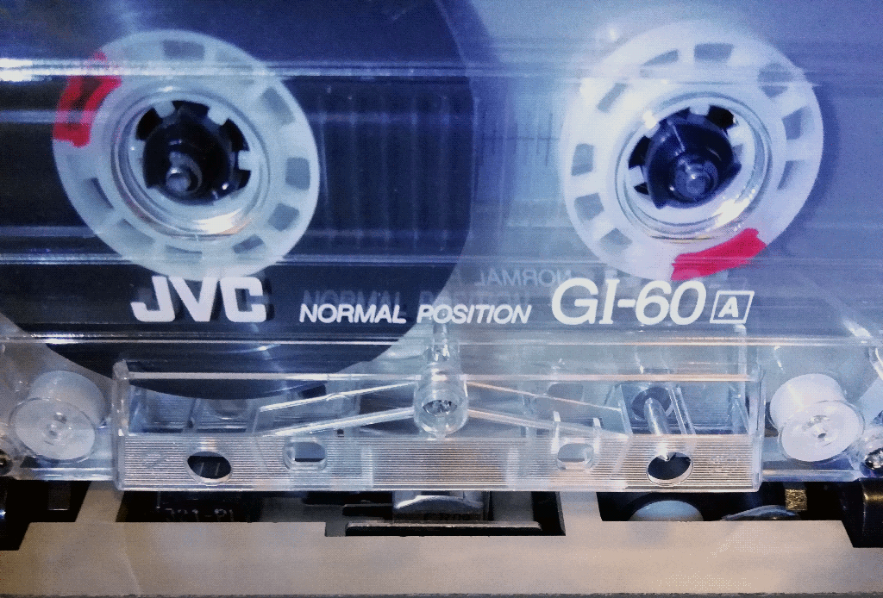Image: A cassette inserted into a cassette player. Notice how the transport fits into the access holes of the cassette.
Insert a cassette such that the side where its tape is exposed faces the transport.
Different cassette players have their ways of loading cassettes. Usually, cassettes are inserted by the compartment door before closing it.
Refer to the user's manual of your cassette player for specific instructions.

B: Playing Cassette Tapes
To begin playback:
- For cassette players with (semi-)mechanical controls, push the play () key until it locks in.
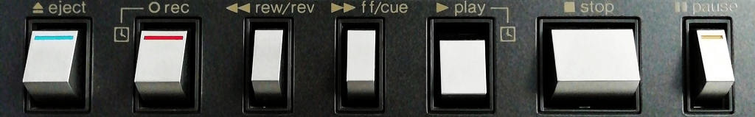Image: Semi-mechanical controls on a cassette deck that is playing, indicated by the dent play key.
Those of you who are accustomed to using touch-sensitive controls may have a bit of hesitation doing this initially.
- For cassette players with buttons (logic controls), press the play () button.
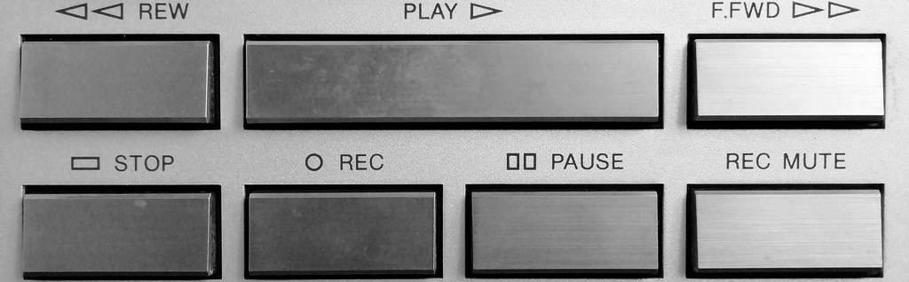Image: Buttons on a cassette deck.
Push/press the fast forward (⏩) or rewind (⏪) keys/buttons to advance the tape quickly in their respective direction.
The triangular symbols are pointing to the direction tape travels through the transport. Boomboxes typically have theirs reversed.
To end playback:
- For cassette players with (semi-)mechanical controls, push the stop (⏹) key until the play () key pops out.
- For cassette players with buttons, press the stop (⏹) button.
The next time you begin playback again, it resumes where you left off.
Refer to the user's manual of your cassette player for specific instructions.

C: Transport Anatomy
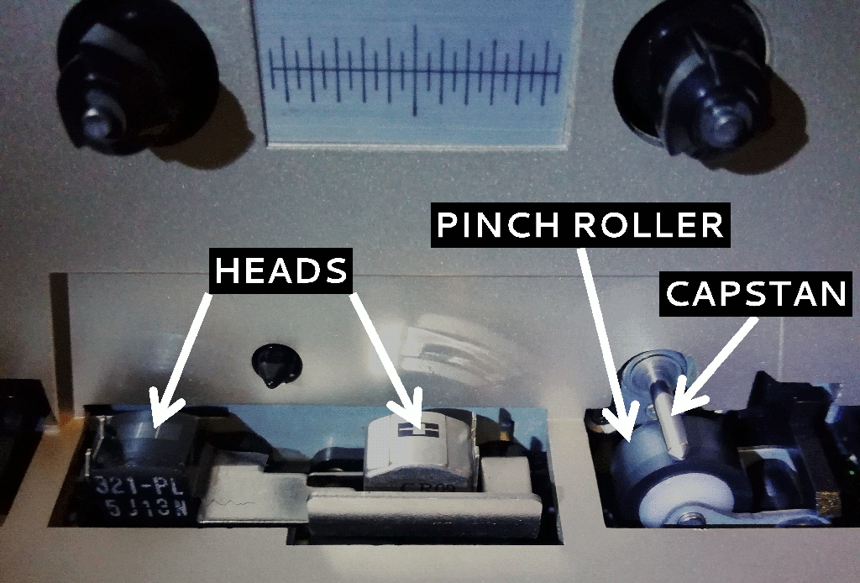
Image: A simple unidirectional transport of a cassette deck.
Heads | "Reads" and/or "writes" magnetic signal from/onto tape.
Capstan | Pulls tape towards the take-up spool.
Pinch Roller | Allows the capstan to do its job.
At the bare minimum, a cassette player has a playback head (metal alloy at center), a capstan and its accompanying pinch roller, and a spinning peg that winds tape around the take-up reel.
It is a common mistake to think that the spinning peg is responsible for tape movement and hence tape speed. Again, this responsibility goes to the capstan, having the closest connection to the motor.

D: Care and Maintenance
Get to know your cassette players, be nice to them, and maintain them regularly. In return, they should give you the best results possible without hiccups.
Here are some ways to maintain healthy relationships between you and your cassette players:
1 Use good tapes. Brand is not always a good indication of quality.
2 Do not touch any of the transport parts, unless required for maintenance or repair.
3 Clean the transport regularly, as explained in [D1: Cleaning].
4 Store them in cold, dry places.
5 Above all, if something does not sound, look, or feel right to you, then stop playing the cassette tape immediately. It is better to be safe than sorry. Clean—as explained below—before playing other cassette tapes.
Refer to the user's manual of your cassette player for additional notes.

D1: Cleaning
Clean the heads, capstans, and pinch rollers after every ten hours of use, or anytime brown matter can be seen.
With a strong cotton swab dipped with 99% isopropyl alcohol, rub gently over the heads and capstans.
Pinch rollers are better off cleaned using a cotton swab dipped with lukewarm water.
Ensure the absence of cotton residues.
Do not use anything abrasive, as these will damage the polished surfaces that are crucial for smooth tape movement. This includes head-cleaning tapes, as they too can be abrasive. In fact, none of my cassette player user manuals mentions anything about head-cleaning tapes, but cotton swabs dipped with alcohol.

IV: Troubleshooting
This section lists some common issues and their common remedies. The obvious ones have been omitted.
First and foremost, check with another tape to confirm that your issue lies on the cassette player and/or tape, and that it is not part of the actual recording.
1 Dull and/or imbalanced sound
- The playback head may be dirty. See [D1: Cleaning] for cleaning instructions.
- The playback head may not have been aligned to the tape tracks.
-- On bidirectional transports, flip the cassette to the opposite side and play in the opposite direction.
-- On portable players with mechanical controls, wiggle the player and the play key.
-- Jiggle the cassette in attempts to center its pressure pad.
-- As a last resort, adjust the playback head azimuth.
- The tape may be worn.
- The playback head may be worn. Replace it, if possible. Worn heads have a good chance to be restored successfully by "relapping."
2 Fluttery sound
- The capstan and/or pinch roller may be dirty. See [D1: Cleaning] for cleaning instructions.
- The mechanism may need some warm-up. Run the cassette player—without a tape if possible—for a while.
3 Stuck tape
- There may be errors in the tape path. Wind the tape by hand to remove any slack. Reinsert the cassette tape into the cassette player, ensuring that the tape passes between the capstan and the pinch roller.
4 Sticky tape
- Fully wind the tape back and forth, then try again.
- Transfer the tape to a different shell.
- Its plastic binder may be shedding glue. It is advised not to use them anymore. Clean the transport right after playing such cassette tapes.
5 Chewed tape
- There may be slacks before you attempted to play the tape.
- A chewed tape can be repaired with some loss by splicing. Clean the transport after recovering the tape.
6 "It's not working."
- Well, like any repairman would say, you have to be more specific than this.
7 "It's still not working."
- Then your cassette player may be poor in quality. Nothing much we can do here.
- If it is a known-good player, then it may require some repair.

V: Repair Services

A: About Repair Shops
Well, this is one of the biggest Achilles' Heel in the world of Compact Cassette.
As of mid-2021, there are still a few repair shops that actually do actual repairs on cassette players and recorders, you just have to find them.
Keep in mind that many repairmen are showing their age by now.
Speaking from experience, some of them are not overly friendly. Some might turn down requests for cheap, plastic devices. Ironically, some "premium" devices may not be technician-friendly.

B: Alternative Option
Alternatively, if you have a real friend whom is expert in—or has a great deal of experience tinkering around—electronics, then your cassette deck may stand a good chance of getting repaired.
To get started, contact that friend—not forgetting to describe your problem—then look for the service manual to your cassette deck ([HiFi Engine] is a good place to start, sign up required).
If your search returns nothing, then you can try a broader search. Look for similar models within your range, it is very likely that they have the same parts and/or configuration, as most of them are designed under a modular approach.
A common repair work involves replacing any worn rubber belts and electronic components such as—and especially—capacitors.
Your friend can also consult the text-heavy [S.E.R FAQ] for more about repairing "consumer electronic equipment and other household devices," including cassette decks.

VI: Trivia
1 The Compact Cassette was originally conceived in 1963 by Phillips as a dictation format; it was not made with high-fidelity sound in mind. I have a demonstration cassette tape copyrighted in 1970, and it sounds rather awful for today's standards.
2 People actually used to wind their cassette tapes with pen or pencil, because doing this on their portable cassette players takes a chunk of power out of their batteries, which were expensive for pocket money back then.
To somehow get over this, some portables run on Ni-Cd or Ni-MH rechargeable batteries. Sadly, these are pretty much unusable nowadays as rechargeable batteries wear out over time. If that is the case, then you can try getting aftermarket equivalents.
3 In cased you missed it: In 2014, Disney's Guardians of the Galaxy features the Sony TPS-L2 (later re-branded as the first Walkman) and the Awesome Mix Vol. 1 mix tape, which was later sold as a soundtrack cassette. It is a major factor to the recent cassette comeback, and hence the prices on related eBay listings, especially on the TPS-L2. I was not moved by any of this though, as my love for cassettes goes all the way back to 2006.
4 The Compact Cassette has also been used for computer data storage and software distribution. There are a number of modern games for vintage computers being distributed via cassette tapes.
5 There used to exist a much-unknown rival to the Compact Cassette: Grundig's DC International, where DC stands for Double Cassette. Introduced to the public in the mid 1960s, it is similar to its rival but was marketed for music from day one. A reason why it did not enjoy its rival's success is Sony's decision to approach Phillips first to settle on exempting licensing fees to the Compact Cassette. This alone got the Compact Cassette on Japanese hands which in turn made it a worldwide success.
6 Arguably, the best home cassette deck is the Nakamichi Dragon, and the best portable cassette recorder is the Sony Walkman WM-D6C.
7 As of mid-2021, you can still get brand new cassette decks and tapes for much higher prices but with much less hassles.
For a new cassette deck, check out the TASCAM 202MKVII or CD-A580, and their TEAC equivalents. For a new blank cassette tape, check out RecordingTheMasters's FOX and the Maxell UR.
For a new portable cassette player, you have to ask around. If its Kickstarter were to succeed, I would recommend RecordingTheMasters's Mystik. I am yet to receive a follow-up email on the matter.

VII: Endnote
There are lots more about cassette tapes to write about. However, this document is made to teach the basics of using cassette tapes and players, sufficient enough to provide anyone a lifetime of warm listening enjoyment.

License
This work is licensed under the Creative Commons Attribution-ShareAlike 4.0 International License. To view a copy of this license, visit https://creativecommons.org/licenses/by-nc-sa/4.0/ or send a letter to Creative Commons, PO Box 1866, Mountain View, CA 94042, USA.
The Compact Cassette logo belongs to the public domain.

End of document. Made with LibreOffice 7.0.

Threshold guesstimated; actual length depends on the tape itself.
International Electrotechnical Commission
That is what I call them.
Actually depends on chemical composition of magnetic particles. If pale, gooey white, then the tape is probably shedding its glue. Clean right after playing such cassette tapes.
With no loose cotton threads.
Meaning not new old stock (NOS).

